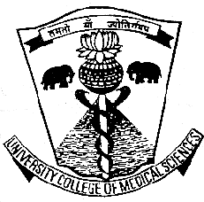

**UNIVERSITY COLLEGE OF MEDICAL SCIENCES**

(UNIVERSITY OF DELHI)

&

**GURU TEG BAHADUR HOSPITAL**

DELHI-110095

PROSPECTUS

SESSION 2020-21

**(Semester Mode)**

**M.Sc. (Radiography & Medical Imaging Technology)**

(Post-graduate Degree Course)

ENTRANCE TEST

**19th Sept. 2020 (Saturday)**

**(Time 11:00 A.M. to 12:30 P.M.)**

**Exam Venue:** University College of Medical Sciences

& GTB Hospital, (COLLEGE BLOCK)

Dilshad Garden, Delhi-110095

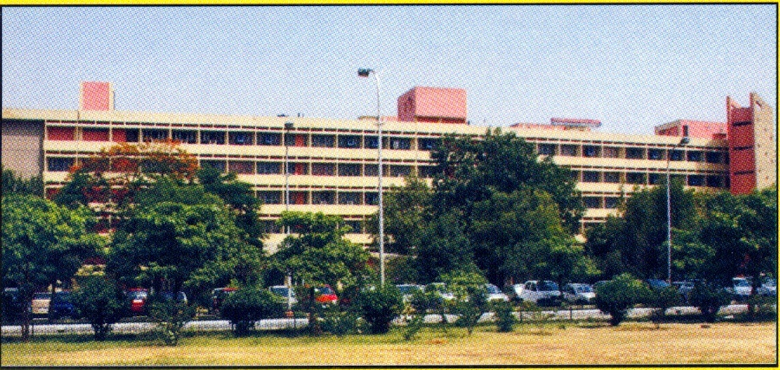

**Price – Rs.800/-**

**IMPORTANT DATES**

1. Opening Date of Application Form (through downloading from college website only) - As per notification of Admission.

**Tuesday, 01st Sept., 2020**

1. Last date for submission of application form duly completed in all respect in the Academic Section, Room No. 210, along with application fee of Rs. 800/- in the form of Demand Draft drawn in favour of ‘The Principal, UCMS’.

**Tuesday, 15th Sept., 2020**

3. Download the Admit Card through College website: i.e. [www.ucms.ac.in](http://www.ucms.ac.in)

**Thursday, 17th Sept., 2020**

4. Date of entrance examination for M.Sc. (R&MIT).

**Saturday, 19th Sept., 2020**

5. Date for notification of the result by the University of Delhi, to be notified on the College Website.

**www.ucms.ac.in**

6. Date for holding the counseling for admission. To be notified on the College

Website

**www.ucms.ac.in**

7. Date of Medical Examination.

**To be notified by the College**

8. Commencement of the Academic Session 2020-2021 **To be notified by the College**

9. Closing date of admission.

**To be notified by the College**

**INCOMPLETE APPLICATIONS SHALL BE SUMMARILY REJECTED.**

**PLEASE READ THE PROSPECTUS CAREFULLY BEFORE FILLING IN THE APPLICATION FORM**

**INTRODUCTION**

Medical Science has made tremendous advances in last two decades. Newer diagnostic and therapeutic modalities like ultrasound, CT scan, MRI, PET scan,etc. are developing at a rapid pace. It is possible to impart this knowledge to the medical students. However, there is acute shortage of supportive technical staff familiar with the newer techniques. X-ray technologist plays an important role in helping the radiologist to make a diagnosis by providing good quality films and helping in various diagnostic and therapeutic procedures. With advances in technology and expansion in medical care, there is increasing requirement of trained radiographers and supervisors to meet the expectations. Hence more and more job opportunities shall be available to the persons trained in X-ray and imaging technology.

With improving standards of medical care and for further upgradation, there is a need for highly qualified imaging professionals in this field all over the country. Further, placements are being solicited by the multinational companies for the bright technologists and highly skilled students as application experts specializing in different fields in imaging technology. There exists a vast untapped potential in this field. Further, with many upcoming institutions for providing training for radiographers, there shall be increasing requirement for tutors. The master’s degree course- (Radiography & Medical Imaging Technology) is aimed at meeting this rising demand as well as at enhancing the quality of care.

**OBJECTIVES**

1. To enhance the standard of knowledge and experience of the students in the field of Medical Imaging Technology (Radiography) and to update them with the newer developments taking place in the field of radio diagnosis.
2. To impart them the experience of teaching, planning and policy making in the organization of department as well as in the selection of equipment and accessories for various procedures.
3. To make the students aware of various radiation safety measures meant for staff members and general public.
4. To develop manpower for supervising and teaching the radiographers and X-ray technologists.

**ADMISSION CRITERIA& PROCEDURE**

**1. REQUIREMENT FOR ADMISSION**

**(i) Eligibility Criteria:**

The Indian national who have passed Bachelor Degree in Sciences (three years course) Medical Technology (Radiography) and Medicine from a recognized University/recognized by MCI respectively**.**

**2. COMPETITIVE ENTRANCE EXAMINATION**

* All the candidates who are found provisionally eligible as per details stated under criteria of eligibility, shall be required to appear in the **entrance examination, which shall be conducted by the University of Delhi on 19th Sept., 2020 at UCMS and GTB Hospital, Delhi-110095**. However, any candidate provisionally allowed to appear at the Entrance Test but found ineligible at the later stage of admission process, shall not be offered the admission. The examination shall be of 90 minutes duration, and shall consist of one paper containing multiple choice questions.
* Candidate will receive a scanned copy of Admit Card by E-mail on **17th Sept., 2020** onward which may be downloaded & get print out of this Admit Card affixing his/her identical photograph which has been used on the application form.
* If candidate does not received his/her Admit Card by E-mail or unable to download in that case candidate can directly collect a copy of Admit Card from the Academic Section, Room No. 210, Second Floor, UCMS from **18th Sept., 2020** on production of valid I.D. proof.
* No candidate shall be admitted to the Examination Hall, unless he/she holds admit card received through E-mail or personally collected from the Academic Section, alongwith valid government ID proof such as Aadhar-Card/Pan-Card/Driving License/Passport/etc. having his/her identical photograph.

**SYLLABUS FOR THE ENTRANCE TEST:**

The general standard for the competitive examination shall be that of passing level in B.Sc. Medical Technology (Radiography) course/ or its equivalent course.

**The medium of examination shall be English.**

**SEATS AND DURATION:**

**The duration of the course is two academic years**: - Six (6) seats are available in the course. The reservation for SC/ST/OBC/EWS and persons with disability seats shall be followed as notified by the University of Delhi. The category wise distribution of seats for the session 2020-21 is as follow:

|  |  |  |  |  |  |
| --- | --- | --- | --- | --- | --- |
| Unreserved | OBC | SC | ST | EWS | **TOTAL** |
| 03 | 01 | 01 | - | 01 | **06** |

**NOTE**: The 13 point Reservation Roster for admission in respect of SC/ST/OBC and EWS candidates shall be followed.

1. **Candidates belonging to SC/ST category**

* The seats reserved for SC/ST shall be filled by the SC/ST candidates only. However, in the case of non-availability of the eligible candidates the reserved seats may be interchanged between the SC & ST. If any seat still remains unfilled, the same shall be left vacant.
* The SC/ST candidate while applying for admission to the course, should enclose a copy of the certificate along with the application form to the effect that he/she belongs to Scheduled Caste/Scheduled Tribe category from any one of the competent authorities as listed below without which, benefit of reservation for Scheduled Caste/Tribe shall not be given:

1. District Magistrate/ Additional District Magistrate/ Deputy Commissioner/ Collector/ Additional Deputy Commissioner/ Deputy Collector/ 1st Class Stipendiary Magistrate/ City Magistrate (not below the rank of 1st Class Stipendiary Magistrate/ Executive Magistrate/ Extra Assistant Commissioner).
2. Chief Presidency Magistrate/Additional Chief Presidency Magistrate/ Presidency Magistrate.
3. Revenue officer not below the rank of Tehsildar.
4. Sub-Divisional Officer of the area where the candidate and/ or his/ her family normally reside.
5. Administrator/ Secretary to Administrator/ Development Officer (Lakshadweep Islands).
6. **Candidates belonging to Other Backward Classes (OBC) category**

* The certificate must mention non-creamy layer status of the applicant (Non-creamy layer status issued by an authority mentioned in DOPT Office memorandum no. 36012/22/93-Estt. (SCT) dated 15.11.1993).
* The OBC applicants who belong to the ‘Non-Creamy Layer’ and whose caste appears in the Central List of the OBCs (notified by the Ministry of Social Justice and Empowerment on the recommendations of the National Commission for Backward Classes available at the website <http://ncbc.nic.in/backwardclasses/>index.html.), shall be eligible to be considered for admission under the OBC category (Validity period of OBC certificate in respect of ‘non-creamy layer’ status of the applicants as per DOPT Office memorandum No. 36036/2/2013-Estt. (Res-I) dated 31 March 2016). The validity of the non-creamy layer certificate shall be for the financial year 2020-2021, issued after 31st March, 2020.
* If the applicant does not have the OBC non-creamy layer certificate of the latest financial year 2020-2021 at the time of registration, the applicant may attach the previously issued (older) OBC non-creamy layer certificate or the acknowledgement slip of OBC non-creamy layer certificate application. However, at the time of admission, the applicant must produce the recent financial year’s (2020-2021) OBC non-creamy layer certificate, issued by the same competent authority. This additional certificate must have reference of his/her already issued original caste certificate.
* Provided that, if any seat(s) reserved for the candidates belonging to OBC category remains unfilled due to non-availability of eligible candidate(s), the same shall be filled up by Open Merit List.

The candidate should not belong to the Creamy Layer. The proof of Non-creamy Layer certificate issued by one of the authorities competent to issue OBC Certificate are indicated below:

1. District Magistrate/Addl. Magistrate/ Collector/ Dy. Commissioner/ Addl. Deputy Commissioner/ Dy. Collector/ Ist Class Stipendiary Magistrate/City Magistrate/ Sub-Divisional Magistrate/ Taluka Magistrate/ Executive Magistrate/ Extra Assistant Commissioner.
2. Chief Presidency Magistrate/Additional Chief Presidency Magistrate/Presidency Magistrate.
3. Revenue Officer not below the rank of Tehsildar.
4. Sub-Divisional Officer of the area where the candidate and his/her family normally reside.

**(c) Reservation under Economically Weaker Section (EWS) applicants**

As per the University of Delhi notifications, Reference No. Aca.I/Reservation of EWSs/2019/63 dated 4th April, 2019 and Reference No. Aca.I/Reservation of EWSs/2019/101 Dated 15th May 2019 issued by Deputy Registrar (Academic), University of Delhi, for the reservation for economically weaker Sections (EWSs) Category, the College has reserved 10% seats for admission for the same from this Academic Year, 2020-21. The eligibility of such applicants will be decided on the basis of fulfilling criteria prescribed in the above notifications. For further details applicants can visit:

[http://www.du.ac.in/du/uploads/Notifications/04042020-Notifications-EWS.pdf](http://www.du.ac.in/du/uploads/Notifications/04042019-Notifications-EWS.pdf)

&

<http://www.du.ac.in/du/index.php?mact=News,cntnt01,detail,0&cntnt01articleid=23723&cntnt01returnid=83>

PROFORMA FOR INCOME AND ASSET CERTIFICATE:

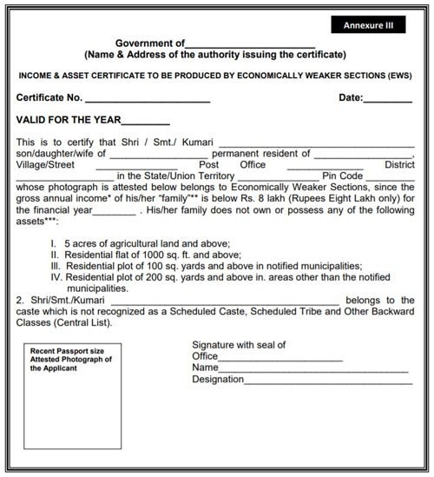

**(d) PWD- Candidates belonging to Physically Handicapped (PH) category**

Three percent (3%) seats are reserved on horizontal basis for the candidate belongings to the Orthopedically Handicapped category (as considered suitable for M.Sc. (R &MIT) course.

The Physically Handicapped candidates having disability of not less than 40% are eligible and may apply as per the guidelines of the University of Delhi for admission.

The application form should be accompanied by certificate certifying valid permanent physical disability issued by a duly notified Medical Board of a District/Government Hospital set up for examining the physical challenged candidates under the provision of the persons with Disability (equal opportunities, protection of rights of full participation) Act 1995. The certificate should indicate the extent of permanent physical disability (i.e. percentage) and it should bear the photograph of the candidate concerned and it should be countersigned by one of the Doctors constituting the Board issuing the certificate.

In case Person with disability (PWD) candidate belongs to SC, ST or OBC category, he/she should also enclose appropriate certificate.

**APPLICATION PROCEDURE**

1. **The Application Form shall only be downloaded from the College website** [**www.ucms.ac.in**](http://www.ucms.ac.in) **and duly filled in application for along with requisite fee in the form of Demand Draft/Pay Order amounting to Rs.800/- in favour of the ‘Principal, University College of Medical Sciences’ payable at Delhi shall be sent to the Principal University College of Medical Sciences, Dilshad Garden, Delhi-110095 on or before the last date, i.e., 15th Sept., 2020. Candidate(s) can also submit the complete application form along with the D.D/Pay order by hand/post in the college.**
2. Application fee of Rs.800/- shall not be refunded under any circumstances, i.e. whether the candidate appears or does not appear in the examination on any ground, or his/her application is rejected on any grounds. No correspondence on this matter shall be entertained.
3. Every candidate must fill the application form in his/her own handwriting and send it in an envelope superscripted “M.Sc. (R&MIT) Entrance Examination-2020” to the Principal, University College of Medical Sciences and GTB Hospital, Dilshad Garden, Delhi-110095.
4. Incomplete application forms, and those received after last date (i.e. after **15th Sept., 2020**) shall not be considered. The College does not take any responsibility for any delay or for the loss of application form in transit.

**The last date for receiving duly completed application form in the College along with requisite fee is Tuesday, 15th Sept., 2020.**

**INSTRUCTIONS FOR FILLING THE APPLICATION FORM**

1. All columns in the application form must be filled in carefully and legibly. Incomplete application form, those not containing the required enclosures, shall be summarily rejected.
2. The application form duly filled in should be accompanied with the following enclosures:

* An attested true copy of Matriculation/Sec. School Examination certificate issued by the University/ Board showing the date of birth of the candidate. (No other evidence for the date of birth of the candidate shall be accepted).
* An attested true copy of the certificate of good conduct from Principal/ Head of the College/ Institution last attended.
* Candidates belonging to other backward classes (OBC category) should enclose latest copy of the caste certificate.
* Candidates belonging to SC/ST/OBC/EWS/PWD should attach the copy of the certificate for its claim.
* Disability candidate while applying for admission to the course, should enclose a copy of Disability Certificate issued by a duly notified Medical Board of a District/Govt. Hospital set up for examining the physical challenged candidates under provision of the person with disability (equal opportunity protection of right of full participation) Act 1995.
* In case Person with disability (PWD) candidate also belongs to SC or ST or OBC category, he/she should also enclose appropriate certificate along with the application form.

**M.Sc. RADIOGRAPHY & MEDICAL IMAGING TECHNOLOGY**

**ENTRANCE TEST-2020**

**Day and Date: Saturday, 19th Sept., 2020**

***INSTRUCTIONS TO THE CANDIDATES***

**Time Schedule**

1. Reporting time 10.00 A.M.
2. Candidates to occupy the allotted seats 10.30 A.M.
3. Issue of test booklets 10.45A.M.

(Candidates shall write their particulars on the cover page of the booklet in ink/ball pen without breaking the seal of the test booklet).

1. Breaking open the seal of the test booklet

The candidates on instructions from the invigilators shall break open the seal of the booklet and take out the answer-sheet. They shall write their particulars on side 1, and shall put their signature in ink on side 2. They shall write the roll number, category (e.g. UR/SC/ST/OBC/PWD/EWS), **with black ball points pen** only. The method is shown below on the specimen portion from the answer sheet. Candidates are advised to be careful in writing these particulars since any wrong entry is likely to be rejected by the computer.

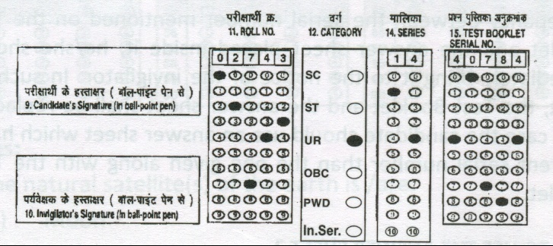

5. Examination starts : 11.00 A.M.

6. Examination concludes : 12.30 P.M.

The candidates reporting late shall be permitted to enter the Examination Hall up to 10.30a.m. No candidate shall be permitted to enter in the Examination Hall after 10.30a.m. under any circumstances. Hence the candidates are advised to reach the Examination Centre by the reporting time so as to avoid any complication at a later stage.

**BLACK BALL POINT PEN**

The candidates shall bring their own black ball point pens. In case, any pencils used, the answer sheet will be rejected by the Optical Mark Reader on which the answer sheet shall be scanned.

**THE TEST**

The test consists of one paper of **90 minutes’ duration.** Each question shall be followed by four possible options marked (A), (B), (C),(D). Of the four options, only one shall be correct or the most appropriate response.

**SCORING AND NEGATIVE MARKING**

For each correct response, the candidate shall get 4 marks. For each incorrect response, one mark shall be deducted from the total score.

**ANSWER SHEET AND CHECKING OF SERIAL NUMBER**

The answer sheet shall be found placed inside the Test Booklet. It shall carry serial number which should tally with the serial number on the Test Booklet. In case the candidate finds any discrepancy between the serial number mentioned on the Test Booklet and the answer sheet placed inside it, he/she should immediately bring it to the notice of the invigilator. In such an event, the Test Booklet and the answer sheet shall be replaced. In no case the candidate should use an answer sheet which has a different serial number than the one given along with the Test Booklet.

**HOW TO USE THE ANSWER SHEET?**

In the answer sheet the serial number of the question is given in the column, which corresponds to question number in the Test Booklet. In each row there are four circles which correspond to the four possible responses to that question. The candidates shall find out the most appropriate response to the question and shall darken the corresponding circle completely with **black ball pointpen** only.

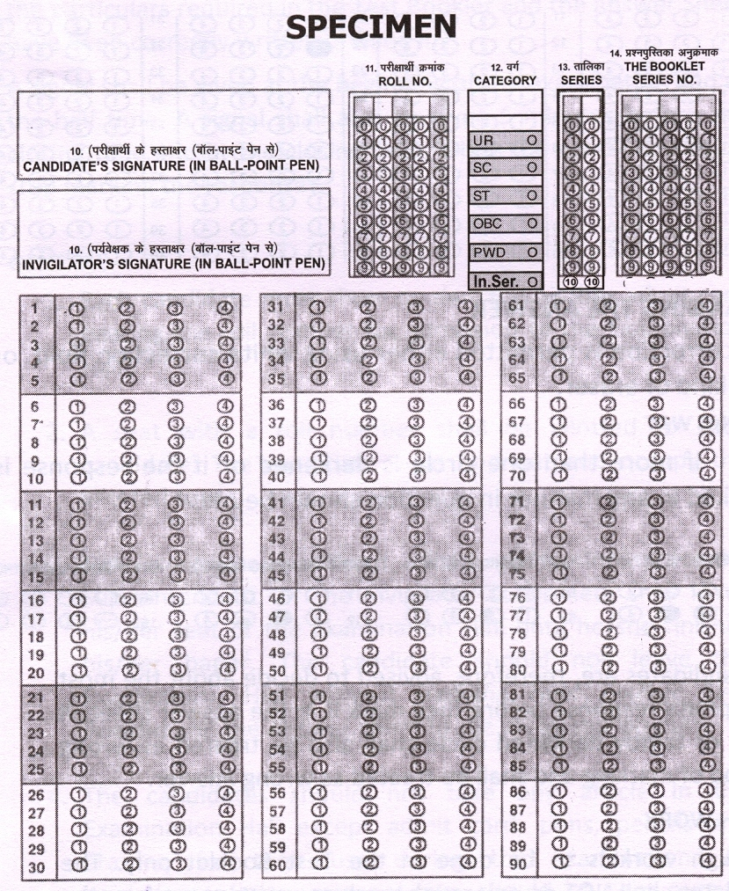

**Examples:**

22. The natural satellite(s) of the earth is /are:

(A) Moon

(B) Planetisimals

(C) Comets

(D) All the above

The correct response to the question is (1) Moon. The candidate shall locate row 22 in the answer sheet and shall darken the circle (1) as shown below:

H:\New Folder (2)\Scan0008 - Copy.tif

**CHANGING THE ANSWER**

No correction is permitted either using white correction fluid or any kind of eraser.

**WRONG WAY**

If more than one circle is darkened or if the response is marked in any manner in question shown below.

H:\New Folder (2)\Scan0008.tif

The candidates are, therefore, advised to decide about the most appropriate response before they mark it in the answer sheet. A lightly or faintly darkened circle shall also be treated as wrong method of marking and shall be treated as wrong answer.

**ROUGH WORK**

All rough work is to be done in the Test Booklet only. The candidates shall NOT do any rough work or put stray mark on the answer sheet.

**NOTE**

During the examination, the Invigilator shall check the admit cards of the candidates to satisfy himself/herself about the identity of each candidate. The invigilator shall also check that candidates have filled in their particulars correctly. The invigilator shall also put his/her signature in the box provided in the answer sheet.

After completing the Test and before handling over the Test Booklet and the answer sheet it should be checked again that all the particulars required in the Test Booklet and the answer Sheet have been correctly written or filled in.

A signal shall be given at the beginning of the examination and at the half time. A signal shall also be given 5 minutes before the closing time and at the closing time, when the candidates must stop marking the responses.

**GENERAL**

1. Each candidate must bring and show on demand his/her admit card bearing the roll number for admission to the Examination Hall & also bring valid ID proof & passport size photograph.
2. A seat with a roll number shall be allotted to each candidate. The candidate must find out and occupy the allotted seat.
3. No candidate, without the permission of the Superintendent, or the Invigilator concerned, shall leave his/her seat or the Examination Hall until he/she finishes his/her paper. The candidate should not leave the Examination Hall without handing over his/her Test Booklet and the Answer sheet to the Invigilator on duty.
4. The candidates should not take any article in the Examination Hall except admit card, pens, pencils and erasers, for their use during the examination. All books/notes/other material, etc. should be kept outside the Examination Hall.
5. The candidates are also advised to bring with them a card/clip board on which nothing should be written so that they have no difficulty in marking responses in the Answer Sheet as the tables provided in the Examination Hall may or may not have even or smooth surface.
6. Smoking in the Examination Hall is strictly prohibited.
7. The candidates must observe perfect silence during the examination and must not indulge in any conversation or gesticulation.
8. Tea, coffee, cold drinks or snacks are not allowed to be taken inside the Examination Hall.
9. Use of any calculating device like slide, log tables or electronic/ manual calculator is strictly prohibited.
10. Cellular phone/ Pager/electronic gadget/smart watch is strictly prohibited in the Examination Hall.

**HOSTEL FACILITY**

The Hostel accommodation may be available subject to availability of rooms.

**PROCEDURE FOR SELECTION**

Out of the eligible candidates who have applied and appeared in the competitive entrance examination, a merit list shall be drawn based on the result of the competitive examination (combined and separately, category wise) as shown below:

1. Combined (Consolidated)
2. Unreserved candidates (Gen.)
3. SC candidates
4. ST candidates
5. OBC candidates
6. Persons with disabilities (PWD)
7. Economically Weaker Section (EWS)

The candidates are required to submit the documentary evidence of having passed their qualifying examination with required percentage of the aggregate marks.

The criteria for selection of students having equal marks in the Entrance Examination shall be follows:

1. In case of equal marks at the Entrance Examination, the candidate securing higher percentage of aggregate marks in the qualifying examination, as mentioned under the admission criteria.
2. In case of candidates having equal percentage of aggregate marks in the qualifying examination, the date of birth would be the basis for selection, i.e. the candidate having higher age shall be offered admission first.
3. After the declaration of the result of Entrance Examination, all eligible candidates shall be required to attend the counseling on given date, time and venue for final offer of admission. Those candidates who do not attend the counseling or reporting late in the counseling shall not be considered for admission.
4. The candidates qualifying for admission shall be informed about their selection by the College by “**Hand/Registered Post/Speed Post/College website”**. The College shall not be responsible for the non-receipt of intimation by the candidates due to any reason.
5. Candidates must also note that the College does not issue or supply any mark sheet of the result of the Entrance Examination and no correspondence on this subject shall be entertained. No intimation to unsuccessful candidates shall be sent.

**IMPORTANT**

1. In case any candidate is found to have furnished false information/certificate, etc. or is found to have withheld or concealed some information in his/her Application Form, he /she shall be debarred from admission to this Course.
2. In case, any document required to be submitted along with application form, is not in order, the application shall be summarily rejected.
3. The candidate must note that he/she should not submit original certificates in any case along with the application form. The College does not take any responsibility for returning the original certificates.
4. Any attempt on the part of the candidate to influence the result of the examination directly or indirectly shall result in his/her disqualification.
5. An application form which is incomplete in any respect, shall not be accepted/processed.
6. The candidates are advised to check and ensure that the Serial Number mentioned on the application form, attendance sheet, admit card and acknowledgement slip are the same. In case any discrepancy is noted, the same should be immediately brought to the notice of the Section Officer (Acad.). Any complaints received after the examination is over, shall not be entertained.
7. The serial Number inscribed on the application form/ admit card shall be considered as the Number for all correspondence purposes till a Roll No. is allotted on the admit card.
8. It shall be the responsibility of the candidate to ensure that the correct address is filled in the application form and on the admit card. If original admit card is not received by mail, the candidates are required to collect duplicate admit cards personally on **18th Sept., 2020** from Academic Section, Room No. 210, College Block. The College shall not be responsible if admit card does not receive by email. The candidate is advised to mention functional email ID in the form.
9. All disputes pertaining to the conduct of the examination shall be within the jurisdiction of the Delhi Courts.
10. The candidates are also advised to keep themselves in regular touch with the College website - [www.ucms.ac.in](http://www.ucms.ac.in) for further updates & information.

**MEDICAL EXAMINATION**

The selected candidates shall have to undergo a medical examination by the Medical Board set up by the College. If in the assessment by the Medical Board a candidate is found medically unfit to join the course, then he/she shall be rejected and shall not be admitted to the course. The decision of the Board shall be final. In such case, the next student in the merit shall be offered admission to the course.

**GENERAL**

**If any candidate selected for admission fails to join the course by the prescribed date, (mentioned in the offer letter) his/her seat shall be offered to the candidate next in the merit in the category, without any further correspondence.**

**COMMENCEMENT OF THE SESSION:- “To be notified by the College”**

Selected candidates shall be required to bring the following certificates in original for verification. Failure to produce the same may result in cancellation of admission:-

1. All original certificates showing the eligibility of the candidate for admission to the 1st year M.Sc. (MIT)Radiography
2. Certificate from the District Magistrate or the officials specified in the prospectus showing that the applicant belongs to Scheduled Caste/Tribe/OBC/PWD/EWS category as indicated in the prospectus
3. Character certificate from the Head of the Institution last attended
4. In case the candidate is already employed, Relieving Certificate and grant of permission to pursue the said course from the Head of the Office/Institution.

**CLARIFICATIONS**

1. Merely appearance at the Entrance Test will not entitle the candidate for admission.
2. Any directions with regards to reservation provision in respect of PWD candidates received from the University of Delhi/Govt. in connection with the admission shall be followed accordingly.
3. The college reserves the right to revise, amend, update or delete any part of this bulletin, rules & regulations at its discretion as & when considered necessary by the competent authority of the College/University of Delhi.
4. The admission offered for the 1st year M.Sc. (Radiography & Medical Imaging Technology)Course shall be **“Provisional”** and in case any discrepancy/ shortcoming/dispute & error with regard to the selection of the candidate is detected at any stage in the eligibility criteria or other norms laid down in the Prospectus for admission to the 1st year M.Sc. (Radiography & Medical Imaging Technology) Course, the admission shall be cancelled and the decision of the College/ University of Delhi shall be final and binding upon the candidate.

**DISCIPLINE**

1. The student shall submit himself/herself to the disciplinary jurisdiction of the Vice-Chancellor and several authorities of the University who may be vested with the authority to exercise discipline under the Act, the Ordinance and the Rules that have been framed by the University from time to time.
2. The Student would undergo the course on full-time basis, no private practice, part-time job being permissible during the duration of the course.
3. University can remove the name of the student from the rolls in case his/her work or conduct is reported to be not satisfactory by the Supervisor/Head of the Department/Head of the Institution. An undertaking to this effect should be obtained from the student at the time of admission.
4. The admission will be terminated if the student is not regular and absent unauthorizedly/ without prior permission.

**RAGGING (Ordinance XV-C)**

1. Ragging in any is strictly prohibited, within the premises of College/ Department of Institution and any part of Delhi University system as well as on public transport.
2. Any individual or collective act or practice of ragging constitutes gross indiscipline and shall be dealt with under this Ordinance.
3. Ragging for the purpose of this Ordinance, ordinarily means act, conductor practice by which dominant power or status of senior students is brought to bear on students freshly enrolled or students freshly enrolled or students who are in any way considered junior or inferior by other students and includes individual or collective acts or practices which-
4. involve physical assault or threat to use of physical force;
5. violate the status, dignity and honor of women students;
6. violate the status, dignity and honor of students belonging to the scheduled castes and tribes;
7. expose students to ridicule and contempt and affect their self-esteem;
8. entail verbal abuse and aggression, indecent gestures and obscene behavior.
9. The Principal of a College, the Head of the Department or an Institution, the authorities of College, of University Hostel or Halls or Residence shall take immediate action on any information of the occurrence of ragging.
10. Notwithstanding anything in Clause (4) above, the Proctor may also *suomoto* enquire into any incident of ragging and make a report to the Vice-Chancellor of the identity of those who have engaged in ragging and the nature of the incident.
11. The Proctor may also submit an initial report establishing the identity of the perpetrators of ragging and the nature of the ragging incident.
12. If the Principal of a College or Head of the Department or Institution or the Proctor is satisfied that for some reason, to be recorded in writing, it is not reasonably practical to hold such an enquiry, he/she may so advise the Vice-Chancellor accordingly.
13. When the Vice- Chancellor is satisfied that is not expedient to hold such an enquiry, his/her decision shall be final.
14. On the receipt of a report under Clause (5) or (6) or a determination by the relevant authority under Clause (7) disclosing the occurrence of ragging incidents described in Clause 3 (a), (b) and (c) the Vice-Chancellor shall direct or order rustication of a student or students for a specific number of years.
15. The Vice-Chancellor may in other cases of ragging order or direct that any student or students be expelled or be not for a stated period, admitted to a course of study in a college, departmental examination for one or more years or that the results of the student or students concerned in the examination or examinations in which they appeared be cancelled.
16. In case any students who have obtained degrees of Delhi University are found guilty under this Ordinance appropriate action under Statute 15 for withdrawal of degrees conferred by the University shall be initiated.
17. For the purpose of this Ordinance, abetment to ragging whether by way of any act, practice or incitement of ragging will also amount to ragging.
18. All institutions within the Delhi University system shall be obligated to carry out instructions/directions issued under this Ordinance, and to give aid and assistance to the Vice-Chancellor to achieve the effective implementation of the Ordinance.
19. The medical council of India (presentation & prohibition of ragging in Medical Colleges/Institutions) regulations 2009 notified in the part III section 4 of the Gazette of India on 3.8.2009 amended form time to time be adhered to.

**Sexual Harassment (Ordinance XV-D) has repelled by the act passed the Parliament the Sexual Harassment of Women at Workplace (Prevention, prohibition and redressal) Act, 2013 (Ref. No. Estab. II(i)/27/ACC/2006 dated 09-01-2014) (**[**www.wcd.nic.in/wcdact/womenactsex.pdf**](http://www.wcd.nic.in/wcdact/womenactsex.pdf)**).**

**AFTER ADMISSION**

No student shall be considered to have pursued a regular course of study unless he/she is certified by the Head of the Department to have attended 75 % of the total number of lectures, practicals and departmental postings conducted in each semester during his/ her course of study provided that he /she fulfilled other conditions. The Head may permit a student to the next Semester who falls short of the required percentage of attendance by not more than 10% of the lectures and seminars conducted during the Semester.

**SPAN PERIOD - UNDER SEMESTER MODE OF STUDY:**

This course is based on Semester System w.e.f. Session 2014-15 and as per the Semester Scheme of University of Delhi. The span period to complete the course shall be 04 (four) years from the date of admission in 1st Semester.

The academic calendar shall be as follows:

**Semester I & III**

|  |  |
| --- | --- |
| **Classes begins** | **23rd July** |
| **Dispersal of classes & conduct of Exam** | **5th January to 25th January** |
| **Winter Vacation** | **26th January to 31st January** |

**Semester II & IV**

|  |  |
| --- | --- |
| **Classes begins** | **1st February** |
| **Dispersal of classes, preparation leave and conduct of exams** | **14th June to 7th July** |
| **Summer Vacation** | **8th July to 22nd July** |

**EMERGENCY DUTIES**

All M.Sc. (R&MIT) Radiography Course students of Part - I & II shall be required to perform emergency duties **during evening and night shifts** in addition to day to day posting. Leave in lieu of night or evening shift will be allowed.

**FEE AND OTHER CHARGES**

Fee for the course will be paid annually.Fees and other Charges for the course is to be paid in cash by the student at the time of admission in the college. Fee structure will be as follows:

1. *Tuition fee (Annual) Rs. 13,000.00
2. Library fee (Annual) Rs. 500.00
3. Athletic fee (Annual) Rs. 10.00
4. Cultural Council fee (Annual) Rs. 5.00
5. N.S.S. fee (Annual) Rs. 20.00
6. University Development Fund Rs. 600.00

(Annual)

1. Faculty Management fee (Annual) Rs. 1,465.00
2. University Enrolment Fee Rs. 200.00

**Total** **Rs. 15,800.00**

***(*) Note: The students belonging to Schedule Caste/ Schedule Tribe Categories whose parents income is such that they are not paying Income Tax be exempted from the payment of tuition fee and admission fee(University circular No.SPLC/Fee Exemp./SC/ST/2015-16 dated 09-09-2015).***

**Note: Security Deposit (Caution Money) of Rs.10,000 (refundable) is to be paid by the student at the time of admission besides Course fee and other charges.**

**NOTE: The above fee amount & structure are subject to change.**

**“Delhi University is partnering with Delhi Police and World Lung Foundation –**

**South Asia in promoting a tobacco free environment. As a step in that direction, smoking is banned in our College”.**

**ADMISTRATIVE STAFF**

Director Professor Anil K. Jain : Principal

Ph: 22582106

Director Professor R.S. Rautela : Medical Director, GTB Hospital

Ph: 22581730

Dr. Shuchi Bhatt : Head, Dept. of Radio-Diagnosis

& Chief Co-ordinator,

B.Sc. (MT)R & M.Sc.(R&MIT) Course

Ph: 22586262/2269-2401 Extn.

Mr. S. Rangabashiam : Deputy Registrar

Ph: 22596637

Dr. A. K. Srivastava : Physicist-cum-R.S.O.

Dept. of Radio-diagnosis

Ph:22586262/ M:-9625900571

Mr. Jitender S. Pal : S.P.A. to Principal

Ph: 22582106

Mr. Sanjay Kumar : Section Officer (Acad.)

Ph: 22582972-74/1202 Extn.

Mr. Hemant Rana : STA (Computer)

(for technical support from 10 AM to 3.30 PM) Ph. 22599273